1. **Final Project Proposal**

The Harry Potter books have always been my favorite to read as a child. I love the adventurous and courageous story of Harry Potter and all the unforgettable, quirky characters. There are also lifelong lessons to be learned in those books. However, what I loved the most was delving into the magical wizarding world of Harry Potter. As a child, I loved creating all the fantastical imagery in my mind and my favorite to imagine was Hogwarts, School of Witchcraft and Wizardry. For my final project, I would like to recreate the Hogwarts great hall. In the movies, it’s these scenes that I feel like captures all the magic and enchantment of Hogwarts and the wizarding world.

Below are some images from the movies of the Hogwarts great hall that I would like to recreate (persons excluded). Essentially, I would like to draw the hall room with long great tables and floating lit candles.

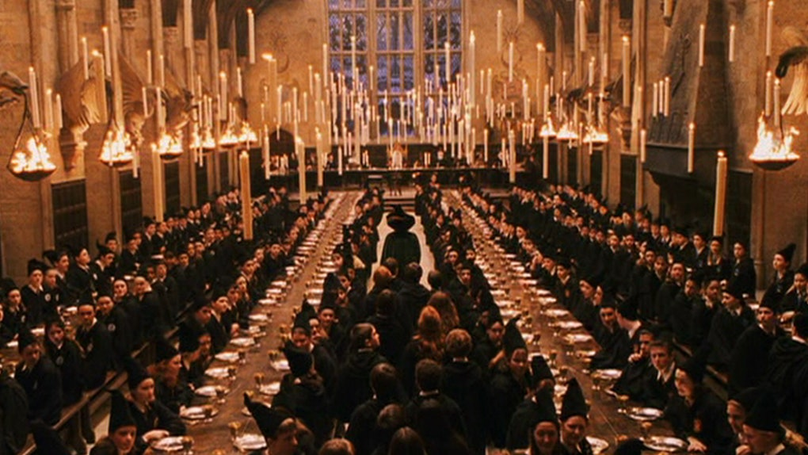

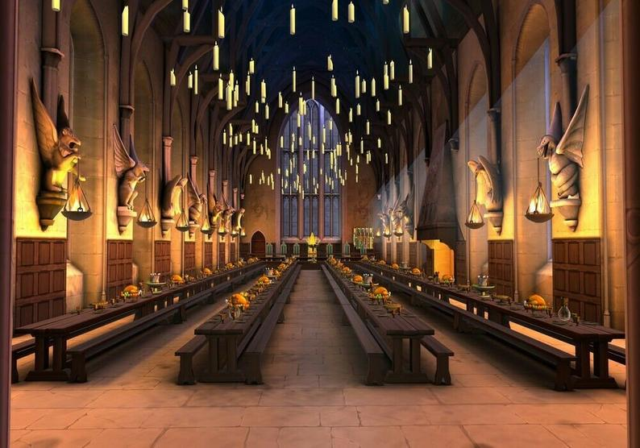

1. What you actually did for your project, with images

I created a dining hall that has three stone walls and a cobblestone floor. I have four rows of five wooden medieval style tables, each with a pair of benches, so that each row of tables looks one long great dining table. High above the tables are a series of scattered floating candles that are lit with a black moving flame, which was generated from a particle emitter. There is a white point light from the viewer’s eye so that the room is illuminated from the viewer’s viewpoint and each candle along the ceiling is also a point light with an orange-yellow light.

Figure: Viewer point light on, Candle point light on

Figure: Candles with black flame

Figure: Viewer point light off, Candle point light on

Figure: Viewer point light on, Candle point light off

1. How your project differs from what you proposed, and why

For my project I was inspired by the magical world of Harry Potter and wanted to recreate the enchanting dining hall in Hogwarts. Unfortunately, due to some challenges I experienced, my graphic did not capture the magic of Hogwarts and instead looks more like a spooky, dim lit medieval dining room. However, I still think my project contains what I essentially wanted to capture, which was a dining hall with long dining tables and floating lit candles.

One of the biggest differences is that my scene is lacking all of the details in the Hogwarts Great Hall. This was because I had difficulty finding free obj files that fit my scene, such as a gargoyle or a wall with windows like the Hogwarts great hall. It was also challenging recreating my own objects on blender. I was also limited to the types of obj files I can use because I had difficulty adding multiple textures to different parts of an object. However, all of the objects in my scene are imported from an obj file and bound to a texture.

Another challenge I ran into, but was somewhat successful, was creating a moving flame on the candles. I wanted to create a realistic fire and, after extensive research, I found a tutorial which taught me how to create a particle generator that can create things such as smoke, fog, or fire. The particle generator allowed me to create a moving candle flame, however, I was having difficultly coloring the flame so that it could be orange-yellow. As a result, as opposed to my proposal, the candles in my scene are lit with a black flame. Although this was unintended, I do like the black flame because it adds a more eerie vibe to the scene.

1. (optional) Any impressive cleverness you want us to know about
2. What you learned from doing this project (i.e., what you know now that you didn't know when you started)

As mentioned above, I learned how to create a particle generator so that I can create a moving flame on my candles. It was challenging, but interesting, and added a really cool effect to my scene. I was also able to get more practice working on other skills we learned in this class such as importing obj files, binding textures, transformations, and adding light sources.

Figure: Close-up of candles